# Northern Caribbean University

## Course: CPTR322: Mobile Application Development

**Assignment: Final Project Documentation**



**Name:** Orrin Reid

**ID#:** 20161989

**Lecturer:** Ricardo Thompson

**Due Date:** December 9, 2020

Table of Contents

Executive Summary 3

Problem & Solution 4

Use Case Diagram 5

Application Architecture 6

Database Schema 7

# Executive Summary

This project is expected to resolve misinformation being distributed and provide a forum in which individuals living in or visiting Jamaica can submit and view reports to be sure what they’re viewing is factual. This will be done through the development of a mobile application called ***JamUpdates*** using Flutter (Dart) which can be accessible to users on both android and iOS devices. There will be an administrative section of this mobile application which will allow the admin(s) of the police force to publish updates and review the incoming reports from users to either approve or disapprove for publication based on validation of the report made by a user.

# Problem & Solution

In an age where information is easily accessible, it is sometimes more tedious to access what is actually truthful. The current issue this mobile application focuses on is providing the Jamaican people and its visitors with concise and accurate updates in relation to the need to know and prevalent matters in the country, such as: COVID-19 status, curfew hours, missing people reports, wanted individuals, major road detours etc. In these troubling times it is difficult for persons to receive these important updates in one forum where they do not have to frantically search the internet only to retrieve misconstrued information. Not only is it difficult for persons to find information, but it is also tedious to make police reports after curfew hours as many cases have been presented on the various news platforms in Jamaica with the difficulty’s individuals face in calling and going to these police stations. Patrons will not only be able to view these updates, but are able to send in reports which will be verified before posting to the public.

# Use Case Diagram

JamUpdates Admin

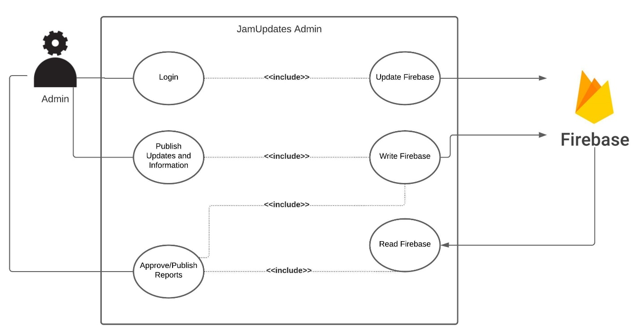

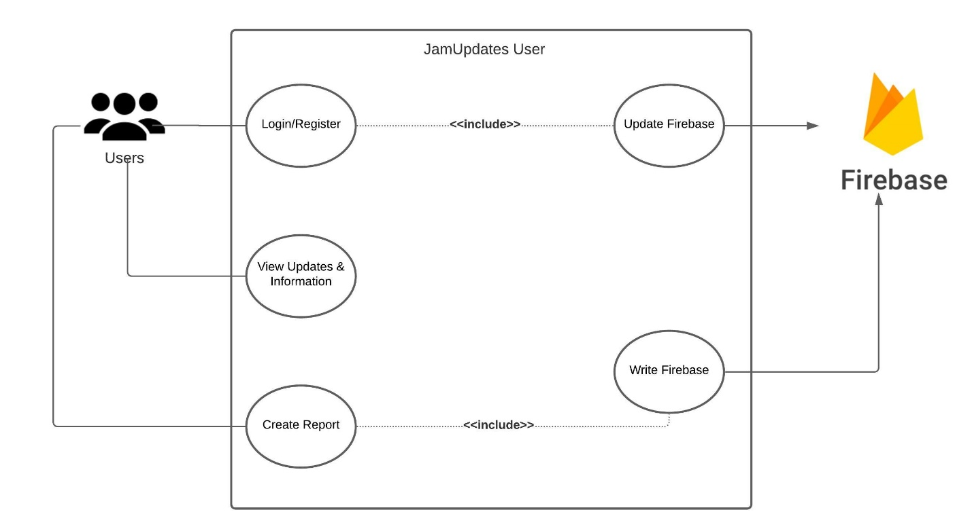JamUpdates User

# Application Architecture

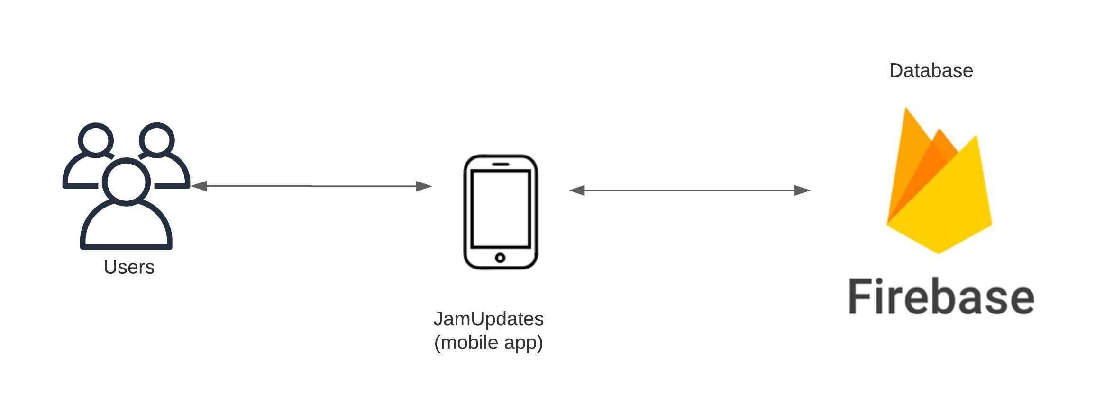

# Database Schema

